

DEVELOPMENT CONTROL PLAN NO.7

EROSION & SEDIMENT
CONTROL

Adopted: 19th February, 2003

Effective from: 1st March, 2003

TABLE OF CONTENTS

1. INTRODUCTION 3
1.1 Why do we need an Erosion and Sediment Control Development Control Plan? 3
1.2 Citation 3
1.3 Objectives of the Plan 3
2. SCOPE OF THIS PLAN 4
2.1 What development does the DCP apply to? 4
2.2 Commencement of the Plan 4
2.3 Relationship to other Environmental Planning Instruments 4
3. USE AND OPERATION OF THIS PLAN 5
3.1 Requirements of the DCP 5
3.2 Maintenance Requirements 5
3.3 Rehabilitation Requirements 5
4. PRINCIPLES OF EROSION AND SEDIMENT CONTROL 6
4.1 General Principles of Erosion and Sediment Control 6
4.2 General Erosion and Sediment Controls. 6
5. EROSION AND SEDIMENT CONTROL MEASURES AND PLANS 9
5.1 Erosion And Sediment Control Plans (ESCP) 9
5.2 What type of Erosion and Sediment Control Plan is required? 9
5.3 Erosion and Sediment Control Plan requirements. 9
5.4 Deemed To Comply Requirements 11
6. CODE OF PRACTICE / CONDITIONS OF CONSENT 12
6.1 Code of Practice / Conditions of Consent for all development that include
works. 12
6.2 Code of Practice / Conditions of Consent - Land subdivision where more
than 2 lots are created. 13
6.3 Code of Practice/Conditions of Consent for Construction Works and Road Maintenance. 14
7. USEFUL REFERENCES 15
8. EXAMPLES OF EROSION AND SEDIMENT CONTROL MEASURES 15

STANDARD EROSION and SEDIMENT CONTROL PLAN INFORMATION SHEET & CHECKLIST 16

ATTACHMENT A 17

ATTACHMENT B 23

INTRODUCTION

Why do we need an Erosion and Sediment Control Development Control Plan?

Soil erosion is a major source of sediment pollution in our waterways. The effects of sedimentation result in:
- Decline in water quality of our waterways.
- Degradation of fisheries habitats.
- Blocked stormwater drainage systems.
- Increased risk of flooding.
- Increased cost of maintenance due to damage to roads, drainage and other infrastructure.
- Costs of restoration works.

Erosion and sediment control offers many advantages for home owners, builders and the building industry, as well as for the environment. These include, but are not limited to:
- All weather access | - Fewer public complaints.
- Reduced stockpile losses. | - A better public image.
- Reduced clean-up costs. | - Reduced risk of fines
- Improved wet weather working conditions. | - Reduced downtime.

This Erosion and Sediment Control DCP has been developed to ensure that the erosion of soil is minimised and if erosion does occur, sediments are prevented from reaching stormwater drains, creeks and other waterways.

Citation

This Plan may be referred to as Pristine Waters Development Control Plan 7 “Erosion and Sediment Control”.

Objectives of the Plan

The objectives of the Erosion and Sediment Control Development Control Plan are to:
- prevent land from being degraded by soil erosion or unsatisfactory land and water management practices.
- protect all the Rivers, Streams and Waterways from being degraded by erosion and sedimentation caused by unsatisfactory land and stormwater management practices.
- promote and protect biodiversity by minimising cumulative impacts of sedimentation in the environment.
- to protect and optimise the performance of assets such as stormwater drainage systems, including sedimentation and gross pollutant traps.
- to ensure that sediment resulting from construction and land development activities is contained on site.
- to prevent sediment entering the urban drainage system thereby reducing its capacity.
- to protect natural watercourses and ecosystems from the effects of siltation.

SCOPE OF THIS PLAN

The Erosion and Sediment Control Development Control Plan applies to all land in the Pristine Waters Council Area.

What development does the DCP apply to?

This DCP applies to all building works, development, subdivision and activities subject to assessment and consent / approval under the provisions of Parts 4 or 5 of the Environmental Planning and Assessment Act 1979 and/or under the Local Government Act 1993 for any proposal or practices which will or may have the potential to involve the:
- Disturbance of the soil surface or placement of fill on a site, which will change the natural contours of the land; or
b) Change in the rate and/or volume of runoff flowing from or land, or directly or indirectly entering a watercourse.

This DCP applies to Council activities (by or on behalf of Council), which will or may have the potential to involve the:
1. Disturbance of the soil surface or placement of fill on a site, which will change the natural contours of the land; or
2. Change in the rate and/or volume of runoff flowing from or over land, or directly or indirectly entering a watercourse.

The DCP does not apply to the following:
- Agriculture;
- Emergency flood mitigation works; and
- Emergency bushfire hazard reduction works.

Commencement of the Plan

The Erosion and Sediment Control Development Control Plan was adopted by Council on and came into effect on

Relationship to other Environmental Planning Instruments

This Plan will prevail except where there is an inconsistency with Nymboida Local Environmental Plan 1986 and Ulmarra Local Environmental Plan 1992 (or such other shire wide Local Environmental Plan that replaces Nymboida LEP 1986 and Ulmarra LEP 1992), North Coast REP 1988 or any State Environmental Planning Policy applying before or after the date of commencement of this Plan.

This plan must be considered in conjunction with all other development control plans that may be applicable to your development proposal. If there is any dispute as to what erosion and sediment controls apply, the controls in this plan, the Erosion and Sediment Control Development Control Plan, must be used.

Reference should also be made to Development Control Plan No. 1 “Engineering Standards for Subdivision and Development”.

USE AND OPERATION OF THIS PLAN

Requirements of the DCP

This DCP requires that any development or activity application must include as part of the application either:

- A ‘standard’ Erosion and Sediment Control Plan (ESCP); or
- A detailed Erosion and Sediment Control Plan (ESCP);or
- A signed statement that the “Deemed To Comply” requirements of this DCP will be installed and implemented (applies to small scale developments only).

The ESCP or the Deemed To Comply Statement must be submitted with the Development or Activity Application.

The principles of erosion and sediment control and general controls to implement these principles must be used when preparing an Erosion and Sediment Control Plan (ESCP) for a site.

See Section 5 detailing what type of Erosion and Sediment Control Plan is required. The conditions of consent that are to be applied are listed in Section 5 of this Development Control Plan.

The Deemed To Comply criteria are specified in Section 5.4

Also see Section 7 on Useful References. Typical examples of erosion and sediment control measures are illustrated in Section 8, at the end of this Development Control Plan. Council officers are available for advice if required.

Maintenance Requirements

All erosion and sediment control measures must be regularly maintained to ensure effectiveness of the control measure at all times.

Rehabilitation Requirements

Rehabilitation of the site, that is revegetation and stabilising the site, as soon as possible after construction is as important as erosion and sediment controls during the construction phase. A program for site rehabilitation must be included as part of the application. The details required will vary according to the type and scale of the proposed development, and nature of the site as well as climatic and seasonal conditions.

PRINCIPLES OF EROSION AND SEDIMENT CONTROL

General Principles of Erosion and Sediment Control

There are 9 general principles that need to be addressed to achieve effective erosion and sediment control. They are as follows:

- Investigate site features to ensure that the land capability and the proposed development are compatible.
- Prepare an Erosion and Sediment Control plan (ESCP) or submit a signed Deemed To Comply statement.
- Expose the smallest possible area of land to disturbance for the shortest possible time.
- Save topsoil for re-use.
- Control run-off, through and from the site.
- Use erosion control measures to prevent on site damage.
- Trap sediment to prevent off site damage.
- Rehabilitate disturbed areas quickly.
- Maintain erosion and sediment controls prior to, during and post construction until the site is stable.

General Erosion and Sediment Controls.

General controls to implement these principles include the following:
- Control water through the site.
- Limit entry/exit to one point and stabilise.
- Install sediment fencing to the low side of the site.
- Topsoil stockpiles to be protected by sediment fencing and/or bunding.
- Store all building materials within a sediment fence envelope.
- Minimise disturbance when excavating.
- Installation of down pipes prior to frame inspection and connection to the stormwater system.
- Maintain all controls in good order at all times prior to and during construction.
- Compact all trenches when backfilling.
- Revegetate/stabilise all disturbed areas as soon as possible.
- Schedule works when rainfall intensity is lower.
- Bunding or sediment/silt fencing around stormwater inlets and within the kerbing on roadways.

- Control water through the site.

Reduce the amount of water flowing through the site. If possible direct upstream flow around the development or building site. Generally, this can be achieved by use of a bank or diversion channel. However the flow needs to be controlled so that erosion is prevented. Sediment/silt fencing, hay bales or other measures may be required across the bank or channel to limit erosion.

- Limit entry/exit to one point and stabilise.

A stabilised access point reduces disturbance of the site and limits transport of sediment from the site. It is recommended that the stabilised access be constructed of 40mm blue metal aggregate or recycled concrete, approximately 150mm deep, 2.5 metres wide and where possible stretch from the kerb line to the slab.

- Install sediment fencing to the low side of the site.

A sediment fence is designed to filter runoff, not concentrate water flows. They need to be installed correctly, i.e. to follow the natural contour with the bottom of the fence in a trench to allow water to flow through and not underneath the fence. The capacity of the fence can be increased by use of a return. Straw bales may be used, although they do not last as long as sediment fences. If straw bales are used, each bale needs to be anchored by at least two stakes. Maintaining sediment fences is extremely important. A break in a sediment fence means that sediment is not trapped. On longer or steeper sites two (2) or more sediment fences may be required.

- Topsoil stockpiles to be protected by sediment fencing.

Stockpiles need to be protected by a sediment fence or bund on the downslope side so they do not become a point source. of sediment. If the stockpile area is prone to high winds or is there for a long time then the stockpile should be covered.

Stockpiling of topsoil can be used in landscaping or rehabilitating the site. This will increase the success of revegetation and reduce development costs.

- Store all building materials within the sediment fence envelope.

All stockpiles, whether they consist of topsoil or building materials, should be protected from erosion by sediment fencing or bunding. All stockpiles are to be placed within the property boundaries of a development site. Stockpiles must not be placed on or near the kerb or gutter or anywhere where there is a clear path for the flow of water to carry sediment into the stormwater drainage system.

- Minimise disturbance when excavating.

By excavating only the area needed for construction the number and extent of sedimentation controls needed are reduced. Existing vegetation on site should be retained where possible. Grass on the nature strip should also be retained where possible.

Vegetation is the most effective form of erosion control as it filters and uses water.

- Installation of down pipes prior to frame inspection and connection to the stormwater system.

Early connection of the roof and guttering to the stormwater system removes the entire roof area from the catchment. By discharging roof water safely away from the site, the pressure on remaining soil erosion and sediment controls are reduced. Connection of the guttering of the building to the stormwater system should be undertaken as soon as practicable after the roof is completed, in time for the frame inspection.

Where buildings are connected to the stormwater system at this stage in construction the site is more easily accessed in a shorter period of time following rain and less maintenance is required for controls.
- Maintain all controls in good order.

All erosion and sediment controls should be inspected regularly and after rain, to ensure they remain effective. Even where controls are correctly installed, maintenance is vital to ensure that they continue to function properly. Sediment fences in particular are subject to damage during construction and require continuous maintenance if they are to be effective. Silt built up along sediment fences needs to be removed.

- Compact all trenches when backfilling.

It is important that service trenches and drainage lines do not subside after backfilling. Adequate compaction will ensure that sediment will not be removed from the site via drainage lines or concentrated runoff. The recommended practice for digging of service trenches is to ensure that material in the backfilled trench is compacted to 75 mm above the surrounding ground level. This allows some subsidence of material, and ensures material is sufficiently compacted to avoid erosion at a later time.

Revegetate/stabilise all disturbed areas as soon as possible

Once construction is completed, the site should be stabilised as soon as possible. This includes construction of all hard paving areas, driveways, landscaping and turfing to decrease the potential for erosion.

Ensuring the site is stabilised when construction has been completed is just as important as implementing and maintaining erosion and sediment controls during construction.

- Schedule works when rainfall intensity is lower.

Preferably, works should be programmed so that the risk of soil erosion occurring during intense rainfall events is minimised. In the Clarence Valley the best time to program construction is between May and October. Between February- March, the risk of soil erosion is greatest due to the likelihood of rainfall events.

EROSION AND SEDIMENT CONTROL MEASURES AND PLANS

Erosion And Sediment Control Plans (ESCP)

The principles of erosion and sediment control and general controls to implement these principles must be used in preparing an Erosion and Sediment Control Plan (ESCP) for a site.

An Erosion and Sediment Control Plan (ESCP) is a document /plan which details control measures to be implemented on a site to minimise the potential for erosion and sedimentation to occur. The plan shows how potential erosion and sedimentation on a site resulting from approved works, development or an activity will be minimised and controlled. An example of an ESCP can be seen on Attachment A.

An ESCP can vary from a simple standard sketch with accompanying notes for minor activities to complex engineering plans and associated documentation for major activities. An ESCP or a Deemed To Comply Statement will be required as part of a development application. The detail required will depend on the scale of the proposed development.

What type of Erosion and Sediment Control Plan is required?

The Table below identifies what type of ESCP is required:

DEVELOPMENT / ACTIVITY | EROSION & SEDIMENT CONTROL REQUIREMENTS
Houses & house extensions, garages, additions to existing commercial & industrial development, 2 lot subdivisions and small scale works. | ‘Standard’ Erosion & Sediment Control Plan; or  Deemed To Comply” Statement “
Houses on steep land & in environmental protection zones, small-scale commercial / industrial development and subdivisions. | “Detailed” Erosion & Sediment Control Plan.
Dual occupancy housing, residential flat development, commercial / industrial development, subdivision, road works and other works. | “Detailed” Erosion & Sediment Control Plan & a Landscape Plan.

*Steep land is land with a slope greater than 1 in 5, (20%).

A copy of an example ‘standard’ ESCP and a Deemed To Comply Statement are contained in Attachment B of this DCP.

Erosion and Sediment Control Plan requirements.

An ESCP is required to ensure that disturbance to the site and construction activities are carried out in a manner that minimises erosion and captures on site any resulting sediment.

An Erosion & Sediment Control Plan (ESCP) must be submitted to Council with all necessary supporting information to enable assessment and approval of the plan. The ESCP must be approved and measures installed before commencement of any site works. A detailed ESCP, i.e. not a ‘standard’ ESCP, must be prepared by a person with suitable qualifications, experience and a demonstrated knowledge of water and soil management.

The following steps should be taken in preparation of an effective erosion and sediment control plan:
- investigate site characteristics, (slope, soil types, etc.)
- integrate clearing and grading with site layout design.
- determine existing and proposed drainage patterns.
- select erosion control practices.
- select sediment control practices.
- outline site rehabilitation program.

The degree of detail submitted to Council with an ESCP depends on the scale of the proposal, the complexity of the site characteristics and the potential environmental impact. A ‘detailed’ ESCP must include the following:
- plan(s).
- supporting information.
- construction details, calculations and notations.

Plan(s) to include;
- locality of the site, north point and scale.
- existing contours and catchment boundaries.
- location and description of existing vegetation and significant natural areas (eg. wetlands).
- location of existing and proposed drainage patterns.
- nature and extent of works, including cut and fill and road works.
- location of all soil and material stockpiles.
- location of site access, proposed roads and any impervious areas.
- location and type of proposed erosion and sediment control measures.
- staging of works.
- site rehabilitation proposals, including final contours.
- ongoing monitoring and maintenance details.

Supporting information - a description of the overall erosion and sediment control strategy, to include;
- description of the existing site conditions.
- description of proposed works and the impact on the site and adjacent areas.
- description of any areas with potential for serious erosion and /or sedimentation and details of the proposed management strategy.
- description of the construction sequence.
- description of the site rehabilitation program.
- description of the maintenance strategy for all control measures.
- description of how the erosion and sediment controls fit into the stormwater management strategy for the site and catchment.

Construction details, calculations and notations to include:
- construction drawings and written specifications must be provided for each type of structural erosion and sediment control measure to be installed.
- specifications for rehabilitation and revegetation works.

Deemed To Comply Requirements

The requirements of this DCP may be satisfied in regard to certain minor developments/activities including dwellings and additions, garages, additions to existing commercial & industrial developments, 2 lot subdivisions and other small scale works if all of the following Deemed To Comply requirements are implemented:

- All erosion and sediment control measures are to be installed prior to the commencement of any work, including cutting and filling.
- All sediment control measures are to be constructed to prevent sediment from leaving the site or entering downstream properties, drainage lines or watercourses.
- Disturbance of the site must be minimized.
- A properly installed sediment control fence must be installed at the downslope perimeter of the disturbed area to prevent sediment and other debris from leaving the site. Sediment fencing is to be trenched in at least 150mm and buried and the ends turned upslope
- Where catchment area is more than 0.5Ha direct up slope runoff around the site, by the use of a diversion bank or channels. These devices may require measures to control erosion depending on the volume of flow anticipated.
- Vehicular access is to be restricted to one stabilised access point which is to be constructed of 40mm crushed stone aggregate or recycled concrete 150mm deep, 2.5m wide and extend from the kerb line to the slab or building line or for at least 15m on rural allotments.
- Stockpiles of erodible materials (sand, soil, spoil and vegetation) must be protected by a sediment fence or bund. If the stockpile area is prone to high winds or is to be there for a long time then the stockpile must be covered.
- Stockpiled material must be stored clear of any drainage line and within the property boundary. NOTE: stockpiles are not permitted on footpaths or roads.
- Immediately following installation of the roof cladding, all guttering and downpipes are to be connected to the stormwater system. Inspection of the frame is not to be arranged until this is completed.
- All erosion and sediment control measures are to be regularly maintained in good working order at all times and inspected for adequacy following any rainfall event.
- All trenches within the development site are to be backfilled and compacted to a level of 75mm above adjoining ground level. This may not apply on public land, consult with Council staff.
- All disturbed areas are to be made erosion resistant by revegetation (i.e. min. 70% coverage), turfing or stabilised by paving on completion of the works and prior to occupation and/or use of the building.

Applicants who choose to utilise the Deemed To Comply option are not required to submit an ESCP but must instead submit a signed Deemed To Comply Statement to Council. A copy of that statement will be issued with and will form part of any subsequent Development Consent.

A copy of the Deemed To Comply Statement is included in Attachment B to this DCP and copies are available at Council’s office.

CODE OF PRACTICE / CONDITIONS OF CONSENT

Listed in the following section are the conditions of consent that apply to development approvals/consents for different types of development/activities. These conditions are the minimum standard that must be achieved. Large-scale developments and development in environmentally sensitive areas may be subject to additional conditions.

Code of Practice / Conditions of Consent for all development that include

works.

- All erosion and sediment control measures are to be installed prior to the commencement of any work, including cutting and filling.

- All sediment control measures are to be constructed to prevent sediment from leaving the site or entering downstream properties, drainage lines or watercourses.

- Disturbance of the site must be minimized.

- A sediment control fence must be installed at the downslope perimeter of the disturbed area to prevent sediment and other debris from leaving the site. Sediment fencing is to be trenched in at least 150mm and buried with the ends turned upslope

- Where catchment area is more than 0.5Ha direct up slope runoff around the site, by the use of a diversion bank or channels. These devices may require measures to control erosion depending on the volume of flow anticipated.

- Vehicular access is to be restricted to one stabilised access point which is to be constructed of 40mm crushed stone aggregate or recycled concrete 150mm deep, 2.5m wide and extend from the kerb line to the slab or building line or for at least 15m on rural allotments.

- Stockpiles of erodible materials (sand, soil, spoil and vegetation) must be protected by a sediment fence or bund. If the stockpile area is prone to high winds or is to be there for a long time then the stockpile must be covered.

- Stockpiled material must be stored clear of any drainage line and within the property boundary. NOTE: stockpiles are not permitted on footpaths or roads.

- Immediately following installation of the roof cladding, all guttering and downpipes are to be connected to the stormwater system. Inspection of the frame is not to be arranged until this is completed.

- All erosion and sediment control measures are to be regularly maintained in good working order at all times and inspected for adequacy following any rainfall event.

- All trenches within the development site are to be backfilled and compacted to a level of 75mm above adjoining ground level. This may not apply on public land, consult with Council staff.

- All disturbed areas are to be made erosion resistant by revegetation, turfing or stabilised by paving on completion of the works and prior to occupation

Code of Practice / Conditions of Consent - Land subdivision where more

than 2 lots are created.

- All sediment and erosion control measures are to be constructed to prevent sediment from leaving the site or entering downstream properties, drainage lines, watercourses or environmentally sensitive areas. Control measures are to be constructed in accordance with the approved Erosion and Sediment Control Plan for the site.

- Erosion and sediment control measures on the perimeter of the site must be installed prior to the commencement of any works.

- All sediment and erosion control measures are to be regularly maintained in accordance with the approved Erosion and Sediment Control Plan for the site. Measures are to be inspected following each rainfall event to ensure effectiveness is not compromised.

- Site rehabilitation proposals are to be carried out in line with the approved Erosion and Sediment Control Plan for the site as soon as final land shaping has been completed.

- Vehicular access to the site is to be restricted and where possible only one access point provided.

- All areas not subject to construction works are to be free from disturbance or damage. These areas may require fencing off or use of other means to ensure compliance with this condition.

- Construction works must be staged to minimise the area of land disturbance exposed at any one time.

- Stockpiles of erodible materials (sand, soil, spoil and vegetation) must be protected by a sediment fence or bund. Stockpiled material must be stored clear of any drainage line and within the property boundary. If the stockpile area is prone to high winds or is to be there for a long time then the stockpile must be covered

- Stripping and stockpiling of topsoil should be undertaken immediately before commencement of bulk earthworks.

- Where possible, major drainage works should be undertaken prior to stripping topsoil eg. construction of major culverts.

- Any stockpiled or unwanted spoil remaining on the site must be removed on completion of construction works.

- All fuelling of plant to be undertaken in a fully bunded area, away from trees/vegetation to be retained.

- Fuel and oils shall be stored in a fully bunded area. The capacity of the bund must be at least 1.2 times the maximum volume stored.

Code of Practice/Conditions of Consent for Construction Works and Road Maintenance.

- Erosion and sediment control measures must be an integral component of all job design and costing.

- Council shall not commence any works unless accompanied by measures that minimise soil erosion and sediment escaping from the site and entering drainage lines, watercourses and environmentally sensitive areas.

- All sediment and erosion control measures are to be constructed in line with an approved Erosion and Sediment Control Plan for the site.

- New road construction, road re-alignments and road maintenance activities should only disturb the minimum amount of land needed within the road reserve.

- Topsoil and vegetation removed during construction works must be re-used to the maximum possible extent.

- Disturbance to vegetation and land at a works site must be minimised.

- All disturbed areas must be progressively stabilised as soon as possible.

- Any native vegetation outside the approved construction/works area but likely to be affected by run-off from the works area must be protected by sediment fencing or a strategy that achieves the same end.

- The officer in charge of the works (works supervisor) has responsibility for ensuring that all erosion and sediment control measures are implemented and regularly maintained in accordance with the approval / approved Erosion and Sediment Control Plan.

- Stockpiles of erodible materials (sand, soil, spoil and vegetation) must be protected by a sediment fence or bund. Stockpiled material must be stored clear of any drainage line and within the property boundary. If the stockpile area is prone to high winds or is to be there for a long time then the stockpile must be covered

- All fuelling of plant to be undertaken in a fully bunded area, away from trees/vegetation to be retained

- Fuel and oils shall be stored in a fully bunded area. The capacity of the bund must be at least 1.2 times the maximum volume stored

- Where possible, major drainage works should be undertaken prior to stripping topsoil eg. construction of major culverts

USEFUL REFERENCES

All erosion and sediment control, pollution control and rehabilitation measures must conform to the specifications and standards contained in:

- “Urban Erosion and Sediment Control” – 1992, Department of Conservation and Land Management (or its most recent published amendment).
- “Urban Erosion and Sediment Control Field Guide” – 1992, NSW Department of Conservation and Land Management (or its most recent published amendment).
- “ Managing Urban Stormwater; Soils and Construction” – 3rd Edition August 1998. NSW Department of Housing (or its most recent published amendment).

EXAMPLES OF EROSION AND SEDIMENT CONTROL MEASURES

See the ‘Urban Erosion and sediment Control Field Guide’, prepared by the Department of Land and Water Conservation, 1996. This is a good basic guide for the following erosion and sediment controls:

Runoff Diversion techniques
Earth perimeter banks and channels
Straw bale perimeter banks
Diversion banks and channels
Level spreaders
Drop down drains
Check dams

Sediment Trapping devices
Sediment fences
Straw bale - Geotextile fabric filters
Sediment traps
Block & gravel kerb inlet sediment trap
Sand bag kerb inlet sediment trap
Excavated sediment trap
Gravel kerb inlet sediment trap
Temporary culvert entry sediment trap
Sediment basins
Grading stabilising structures
Construction Exits/entrances
Temporary access culvert
Buffer zones

Channel stabilisation
Revegetation techniques
Trenching Activities

STANDARD EROSION and SEDIMENT CONTROL PLAN INFORMATION SHEET & CHECKLIST

The following information is to be provided on the “Standard Erosion & Sediment Control Plan’ base plan;
- Location of dwelling or building.
- Direction of slope/fall of the site.
- Contour lines, if possible.
- Locate where site is to be disturbed or cleared and where existing vegetation is to remain.
- Location of sediment fence.
- Location of stabilised entry/exit point.
- Location of stockpiles, eg. topsoil, sand, building materials.
- Location of diversion bank & channel, if required.
- Location of other erosion & sediment control measures.

CHECKLIST

- Uphill water directed around the building site, by use of a bank or channels.
- One stabilised vehicular entry/exit point.
- Sediment fencing installed on the lower side of the site.
- Stockpiles of erodible materials (eg. topsoil, sand, spoil &vegetation) protected by sediment fencing.
- Stockpiled material within property boundary and clear of drainage lines.

Standard Conditions of Consent that apply to all Development that includes Works.

- All erosion and sediment control measures are to be installed prior to the commencement of any building work, including cutting and filling.
- All sediment control measures are to be constructed to prevent sediment from leaving the site or entering downstream properties, drainage lines or watercourses.
- Disturbance of the site must only occur on areas indicated in the approved plans.
- A sediment control fence must be installed at the downslope perimeter of the disturbed area to prevent sediment and other debris from leaving the site.
- Direct up slope runoff around the site, by use of bank or channels.
- Vehicular access is to be restricted to one stabilised access point.
- Stockpiles of erodible materials (sand, soil, spoil and vegetation) must be protected by a sediment fence.
- Stockpiled material must be stored clear of any drainage line and within the property boundary. NOTE: stockpiles are not permitted on footpaths or roads.
- Immediately following installation of the roof cladding, all guttering and downpipes are to be connected to the stormwater system. Inspection of the frame is not to be arranged until this is satisfactorily completed.
- All erosion and sediment control measures are to be maintained in good order.
- All trenches are to be backfilled and compacted to a level of 75mm above adjoining ground level.
- All disturbed areas are to be made erosion resistant by revegetation, turfing or stabilised by paving on completion of the building works.

ATTACHMENT A

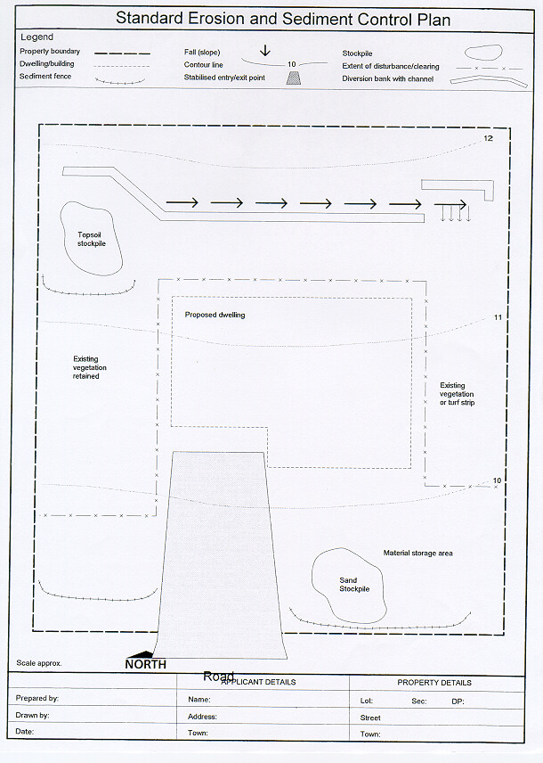

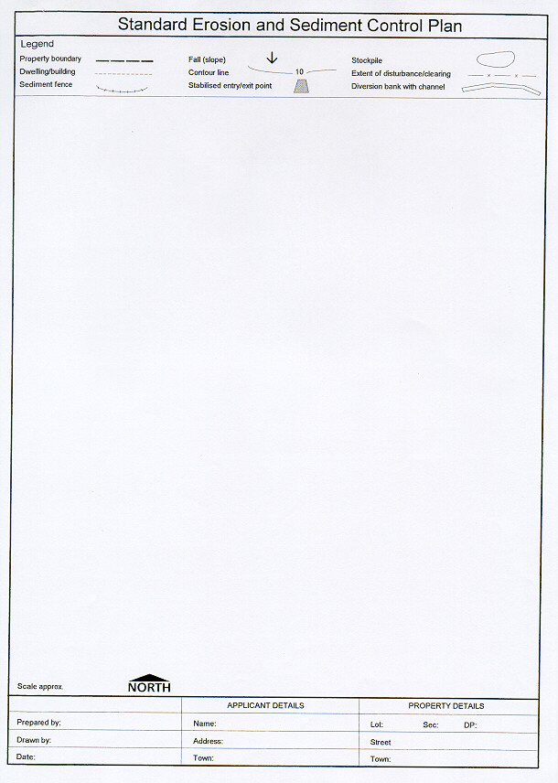
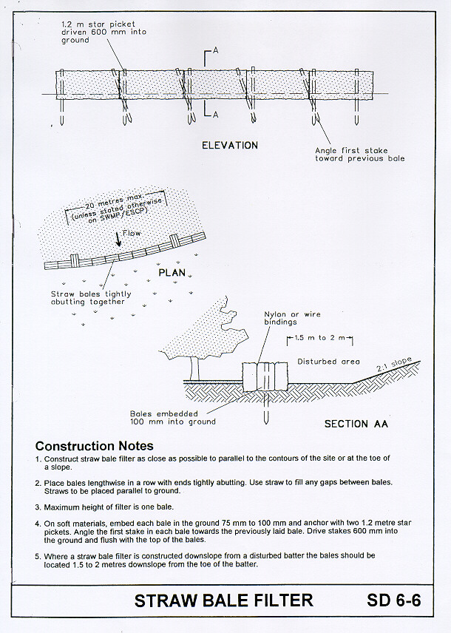
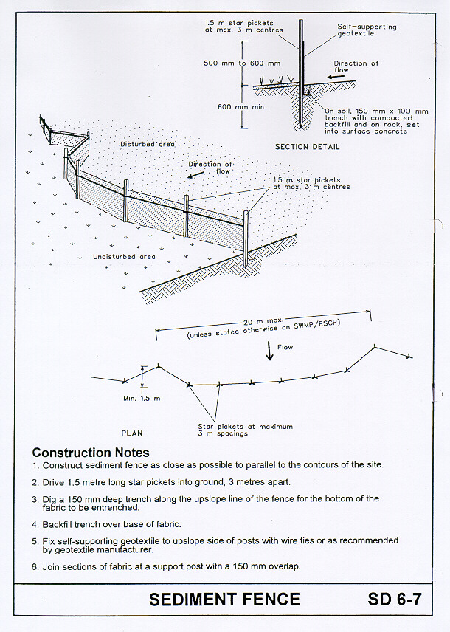
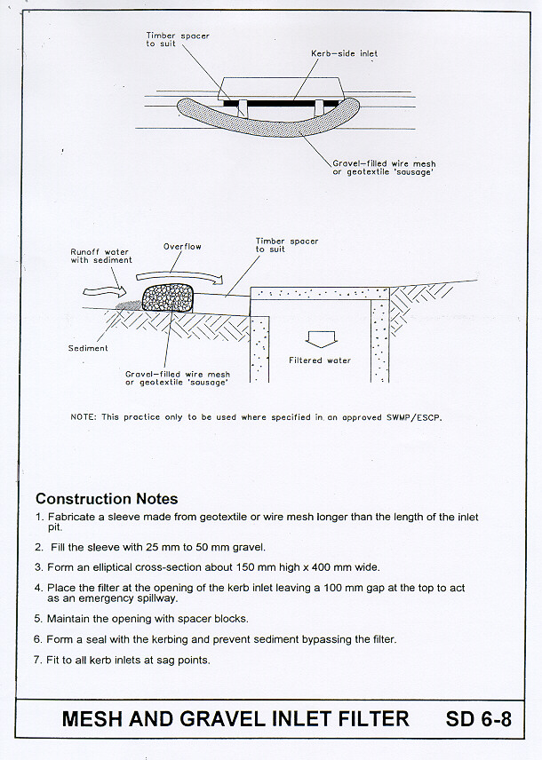

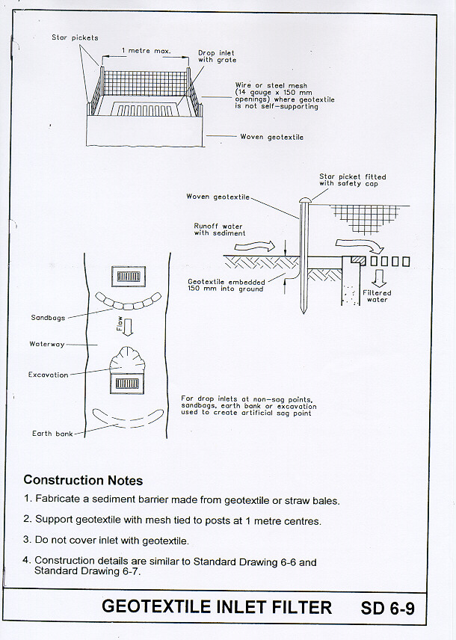

ATTACHMENT B

DEEMED TO COMPLY STATEMENT FOR EROSION AND SEDIMENT CONTROL FOR SINGLE DWELLINGS AND OTHER MINOR DEVELOPMENTS

- All erosion and sediment control measures are to be installed prior to the commencement of any work, including cutting and filling.

- All sediment control measures are to be constructed to prevent sediment from leaving the site or entering downstream properties, drainage lines or watercourses.

- Disturbance of the site must be minimized.

- A sediment control fence must be installed at the downslope perimeter of the disturbed area to prevent sediment and other debris from leaving the site. Sediment fencing is to be trenched in at least 150mm and buried with the ends turned upslope

- Where catchment area is more than 0.5Ha direct up slope runoff around the site, by the use of a diversion bank or channels. These devices may require measures to control erosion depending on the volume of flow anticipated.

- Vehicular access is to be restricted to one stabilised access point which is to be constructed of 40mm crushed stone aggregate or recycled concrete 150mm deep, 2.5m wide and extend from the kerb line to the slab or building line or for at least 15m on rural allotments.

- Stockpiles of erodible materials (sand, soil, spoil and vegetation) must be protected by a sediment fence or bund. If the stockpile area is prone to high winds or is to be there for a long time then the stockpile must be covered.

- Stockpiled material must be stored clear of any drainage line and within the property boundary. NOTE: stockpiles are not permitted on footpaths or roads.

- Immediately following installation of the roof cladding, all guttering and downpipes are to be connected to the stormwater system. Inspection of the frame is not to be arranged until this is completed.

- All erosion and sediment control measures are to be regularly maintained in good working order at all times and inspected for adequacy following any rainfall event.

- All trenches within the development site are to be backfilled and compacted to a level of 75mm above adjoining ground level. This may not apply on public land, consult with Council staff.

- All disturbed areas are to be made erosion resistant by revegetation (i.e. min.70% coverage), turfing or stabilised by paving on completion of the works and prior to occupation and/or use of the building or, all necessary erosion and sediment control devices are to be left in place.

I hereby agree to install and implement all of the above measures to control erosion and sediments at the premises described below –

Lot No: …………………… D.P. ………………….. Section No: ……………...

Street Address: ……………………………………………………………...................

………………………………………………………………………...

Name: …………………………………………………………………………………

Signature: ……………………………………………….. Date: …………………….

